**EDUCATIONAL ORGANIZATION USING SERVICES NOW**

**Team ID: NM2025TMID13728**

**Team Members: 4**

**Team Leader: ASWIN S**

**Team Member: GOKULESH A**

**Team Member: JESU AAKASH A**

**Team Member: DINESH S**

**Problem Statement:**

In educational organizations, managing students, faculty, and administrative staff often becomes challenging due to large volumes of users and different levels of access requirements. Without a structured system, role assignment, group management, and secure access become inefficient and error-prone.

**Objective:**

To implement ServiceNow for user, group, and role management in an educational organization, ensuring secure access, smooth collaboration between staff and students, and automated workflows for academic and administrative tasks.

**Skills:** Tensorflow **Milestone 1 :**

**Creating a Update Set**

Creating a Update Set

1. Click on All >> Local update sets .

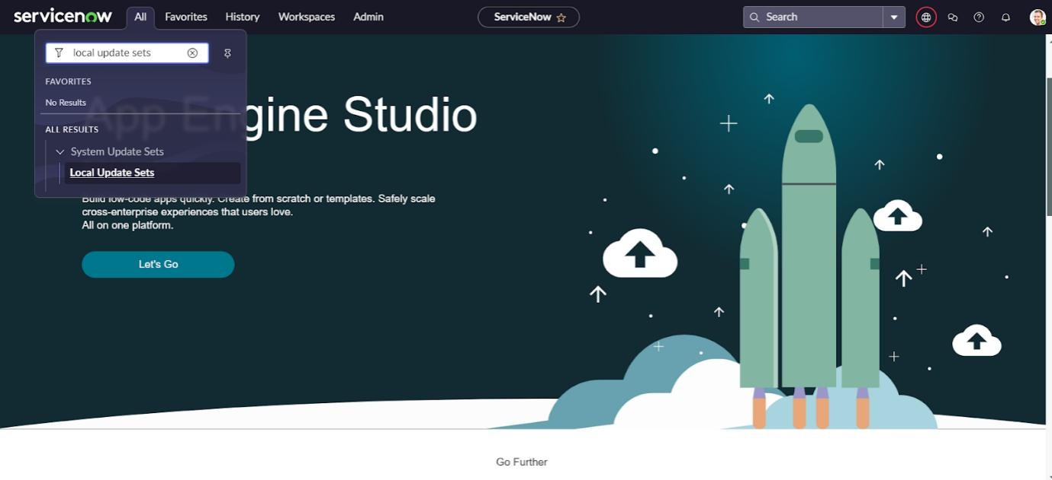

1. Click on new

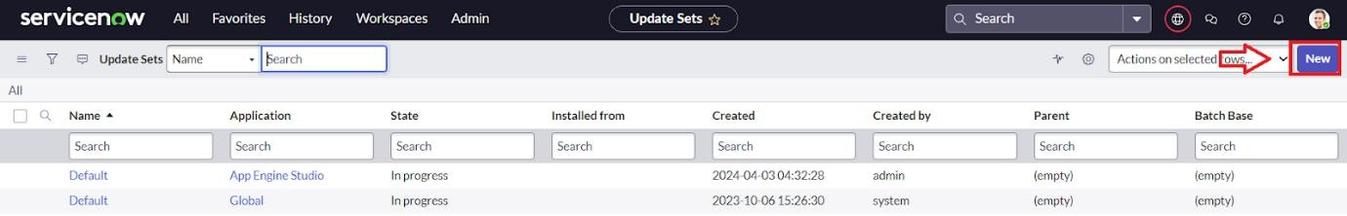

3.Enter the Details Name: Educational Organisation >> Click on Submit and make Current.

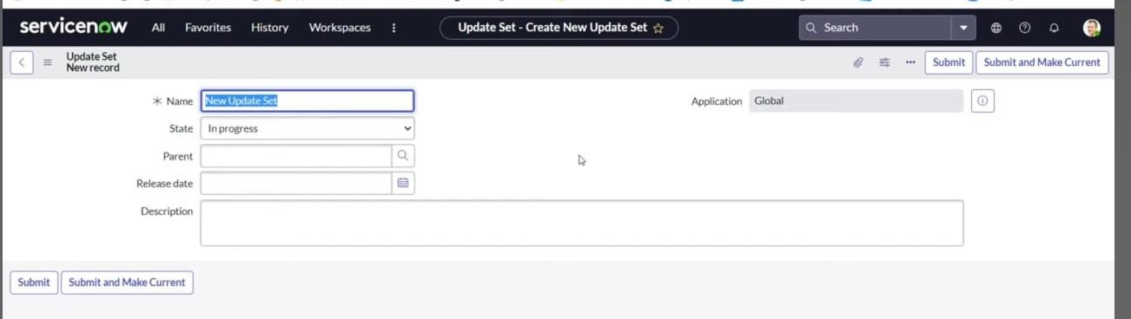

**Milestone 2 :**

**Creating a Table**

**Activity1: Creating Salesforce Table.**

* All >> Tables.

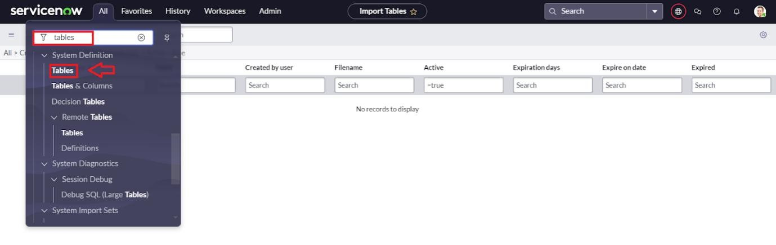

* Click on new

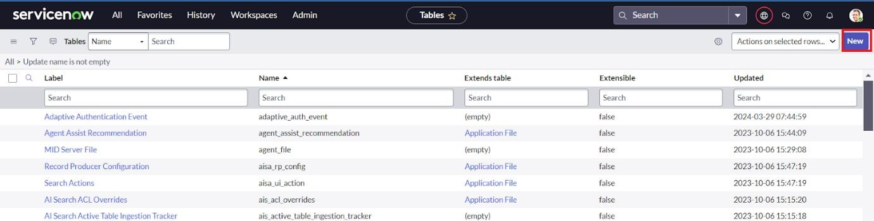

* Enter the Label(Anything you want): Salesforce >> Click on Name it will Automatically generate Api name.

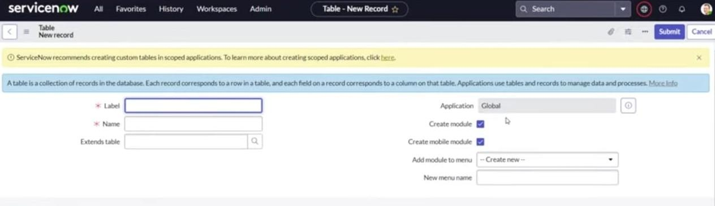

* Create columns as given below,Double Click on Column label and Enter the Column labels and click on the tick mark >> Give Type as given .

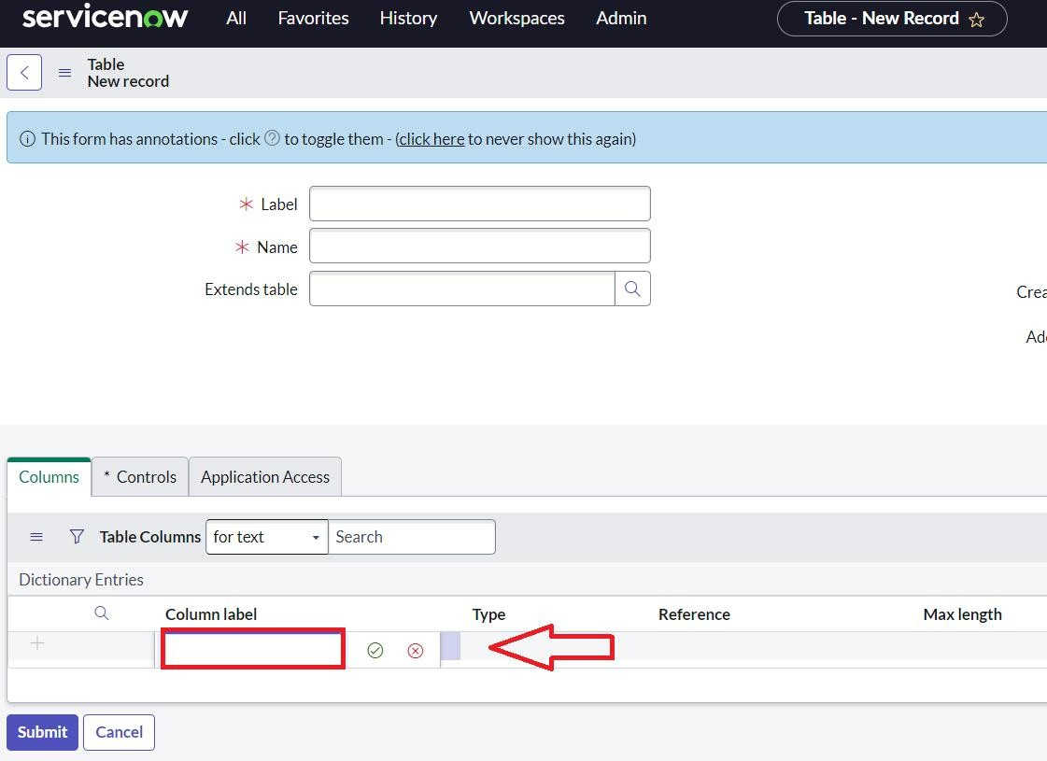x

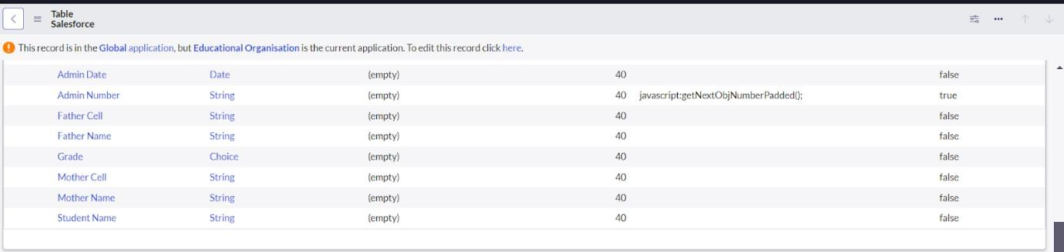

* For “Admin Number” Give Display as True and right click on the toggle bar on top >> save.

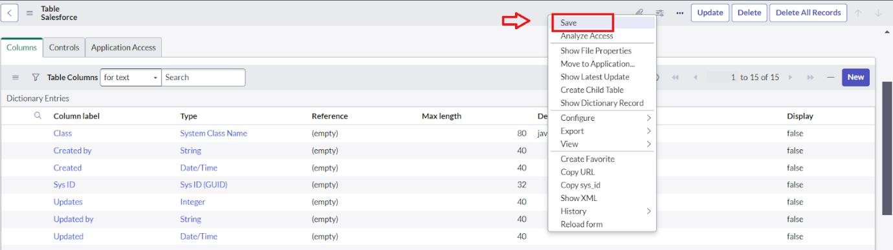

* Click on controls >> Enable Extensible.

• 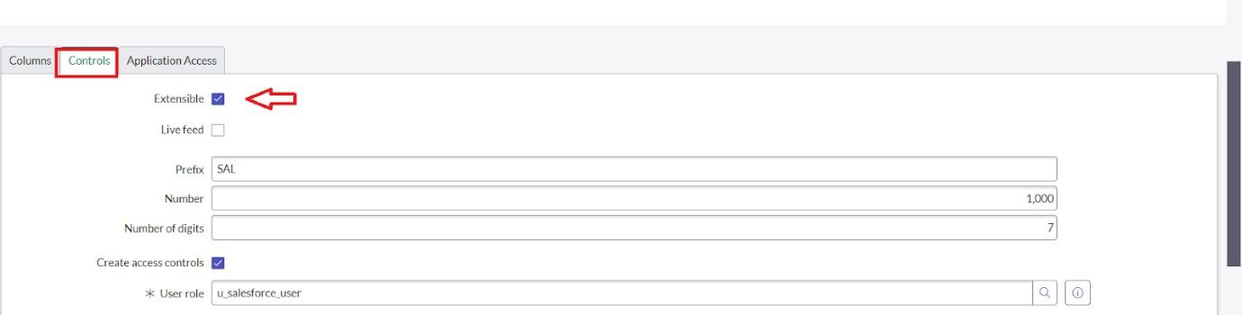

* Click on “Admin Number” column, In Related Links Click on Advanced View >> Default View (Enable Use dynamic default) >> select Get Next Padded Number in Dynamic default value >> Update .

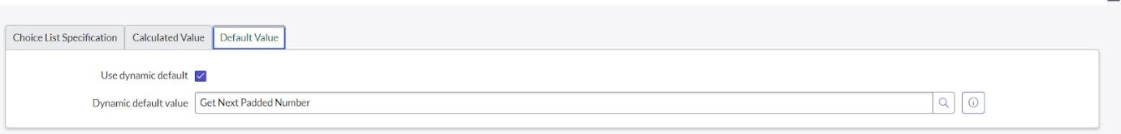

* Click on “Grade” Column >> Click on Choices and give Label,Value and Sequence as given below.

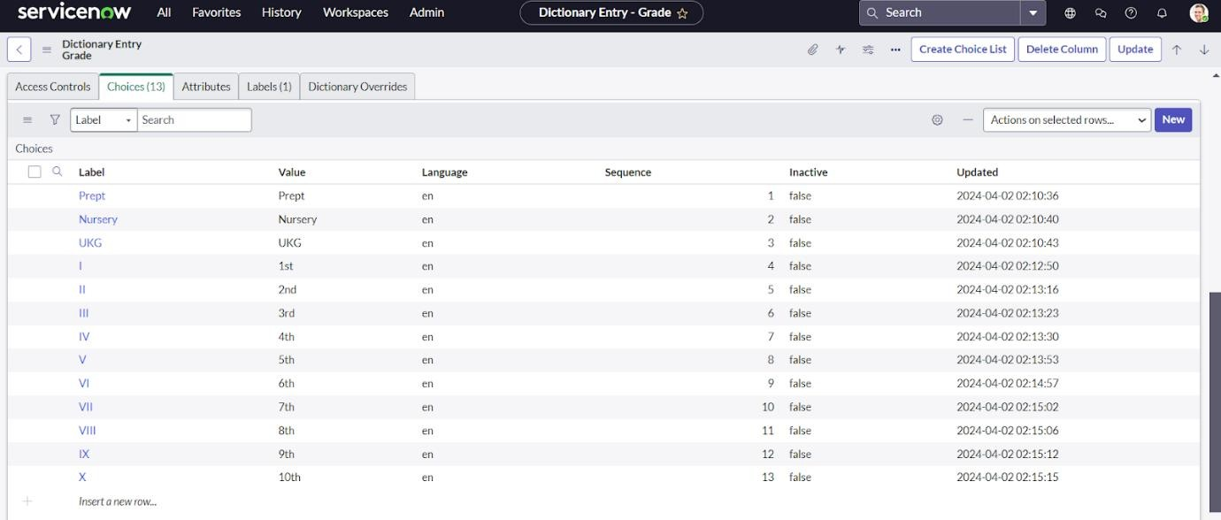

**Activity2: Creating Admission Table**

* Create an Admission Table with Columns given.
* Select Extends Table >> Salesforce and also Select Add module to menu >> Salesforce.
* Create Fields as shown

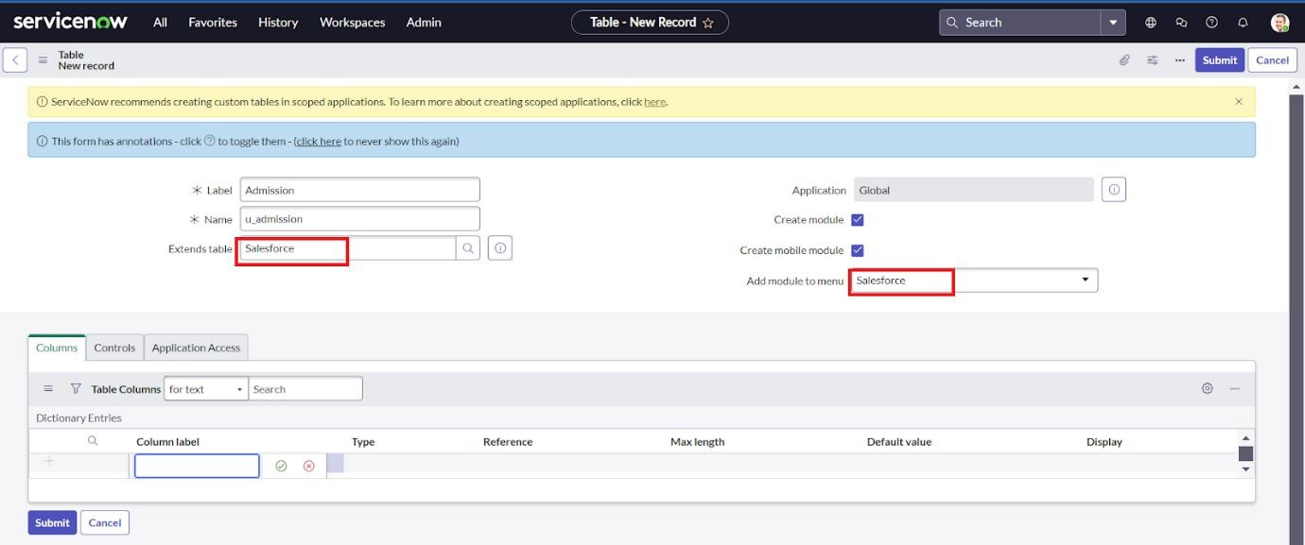

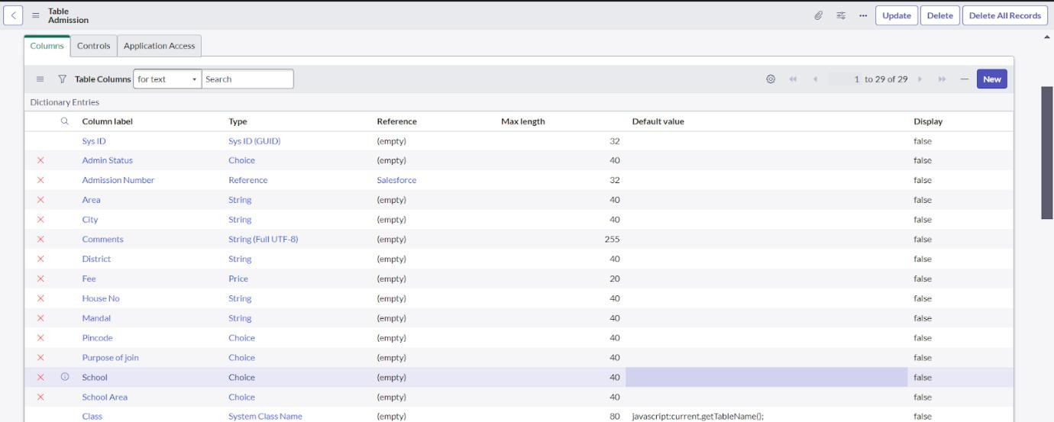

* Create choice for Admin Status as:

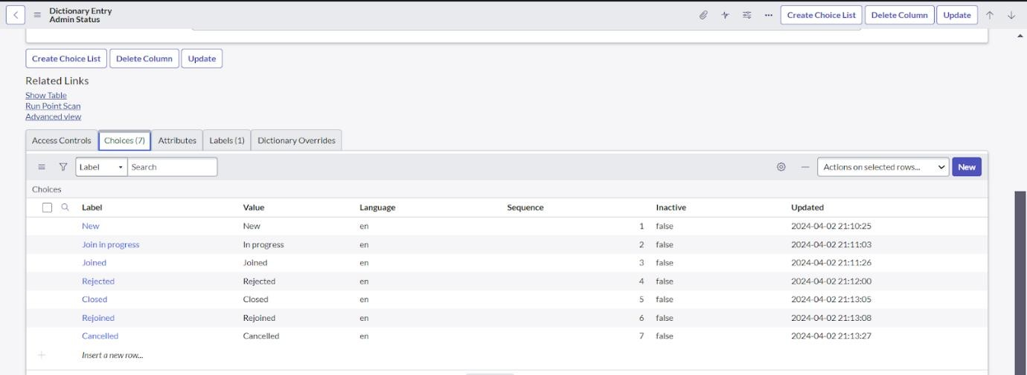

* Create choice for Pincode as:

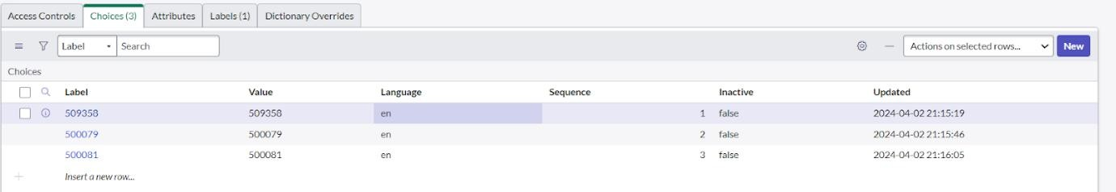

* Create choice for Purpose of Join as:

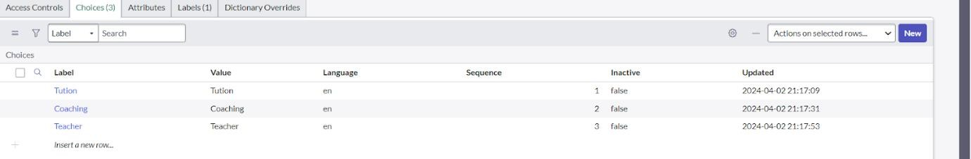

* Create choice for School as:

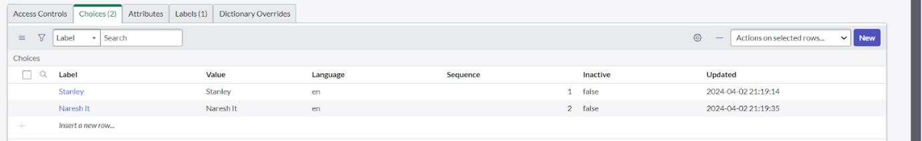

* Create choice for School Area as:

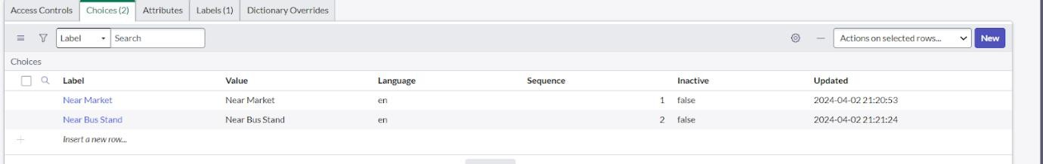

**Activity3: Creating Student Progress Table** • Create a Student Progress Table with Columns given.

* Select Add module to menu >> Salesforce.
* Create Fields as shown:

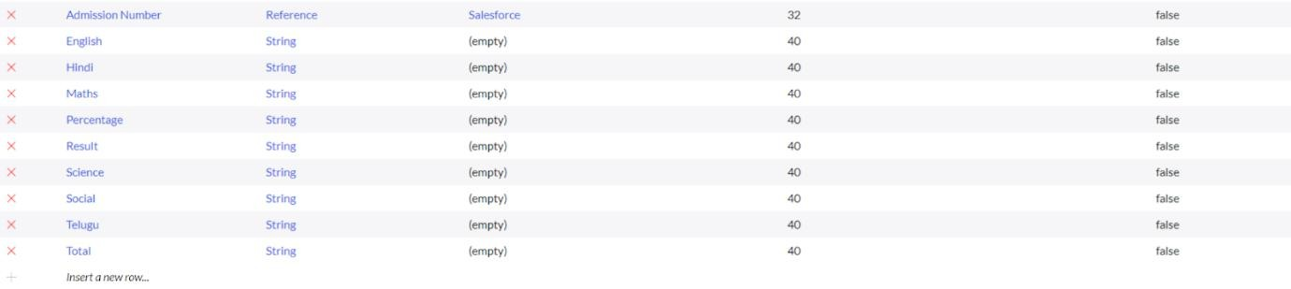

**Milestone3: Form Layout**

**Activity1: Configuring Table form for Student Progress Table** • In the Student Progress Table Page , Click on Layout form .

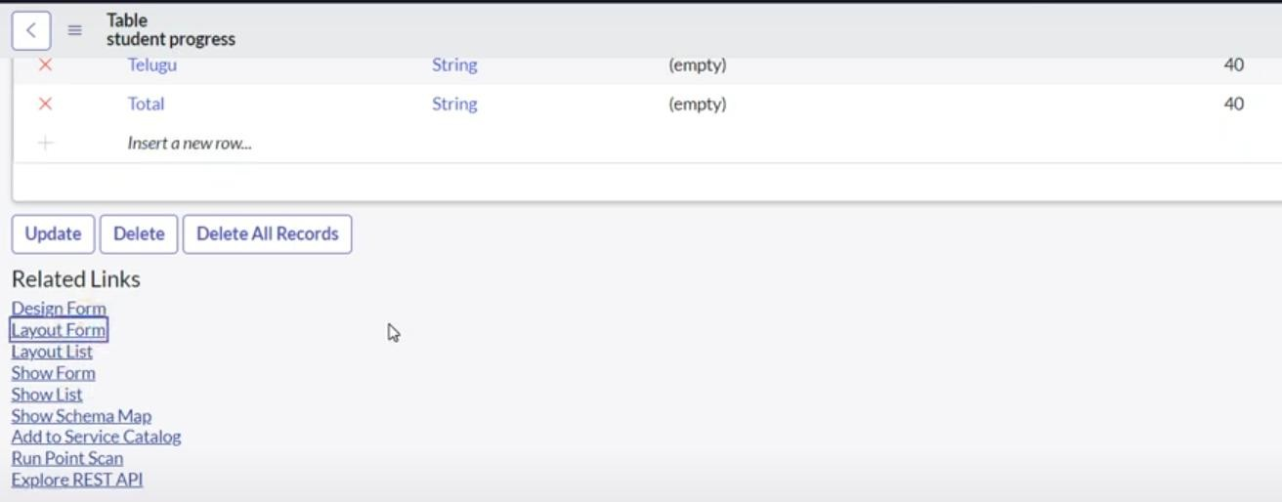

* Click on Admission Number [+] .

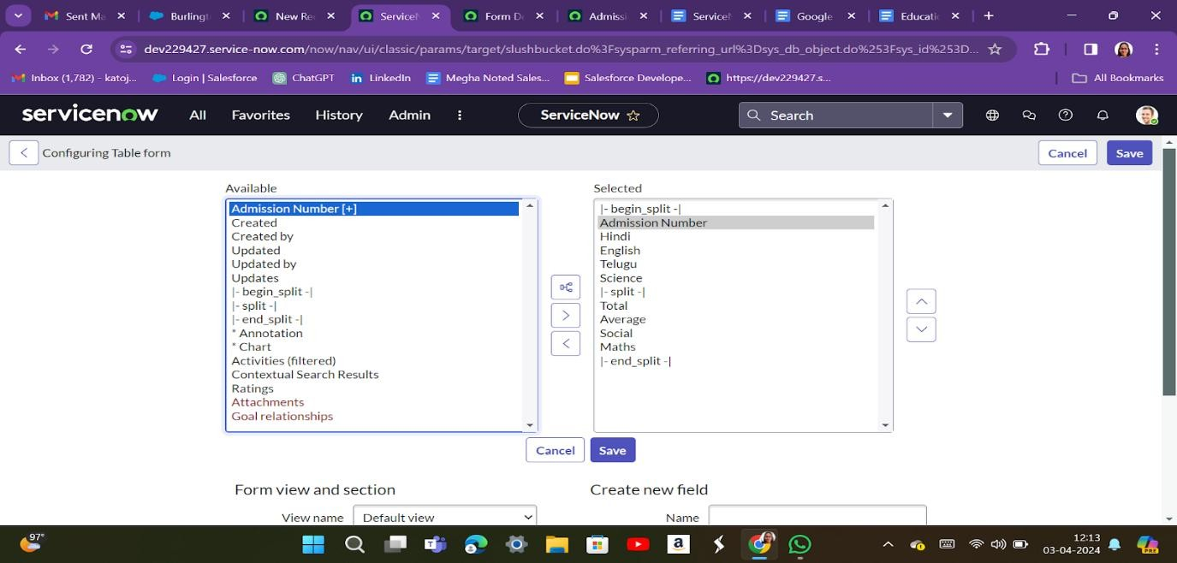

* Select below Admission Number fields in Available side and send it to selected side as below >> save.

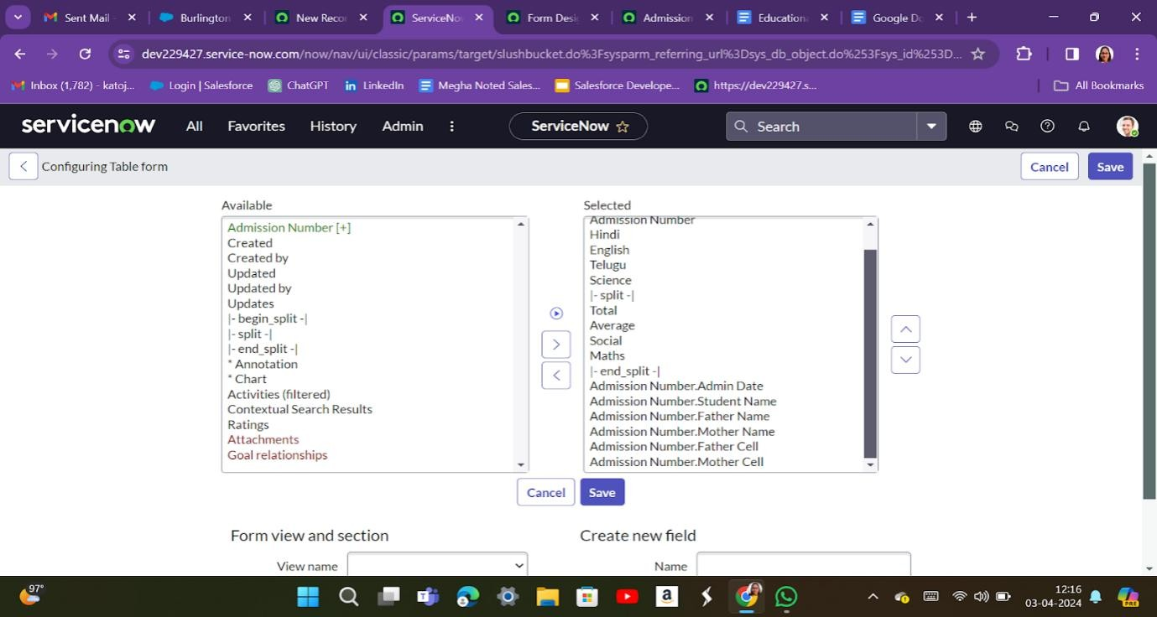

**Milestone4:Form Design**

**Activity1: Creating Form Design for Salesforce Table**

1. All >> System Definition >> Tables .
2. In Label Search for Salesforce and open .

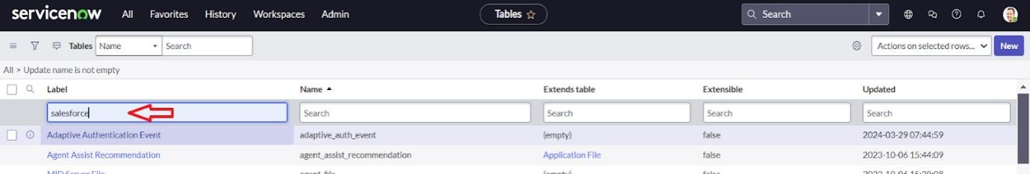

1. Right Click on top Toggle >> Configure >> Form Design.

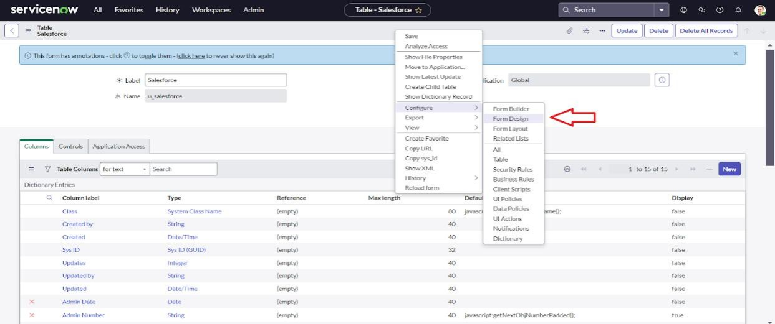

1. In drop down select Salesforce(u_salesforce).

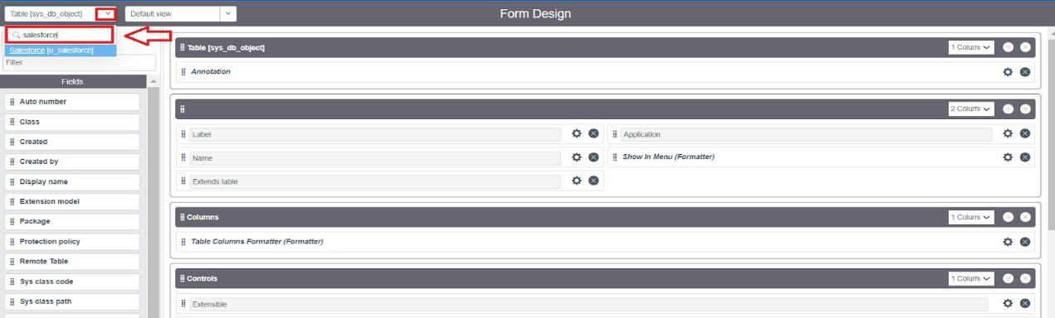

1. Drag and drop the fields to the left side as below.

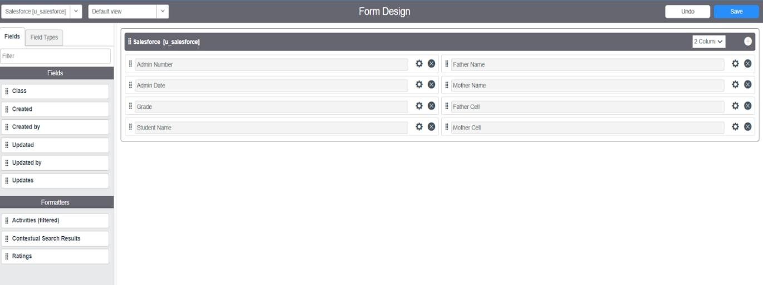

6.Save.

**Activity2: Creating Form Design for Admission Table**

Follow the same steps as Activity1,Configure the fields as below and Save.

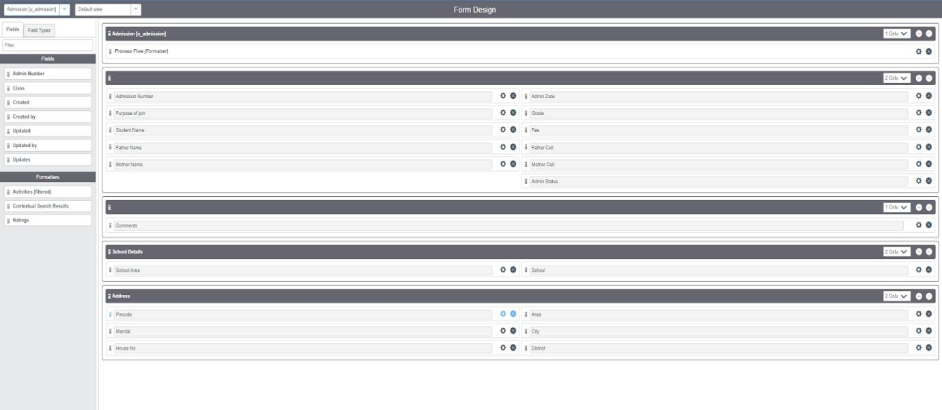

**Activity3: Creating Form Design for Student progress Table**

Follow the same steps as Activity1,Configure the fields as below and Save.

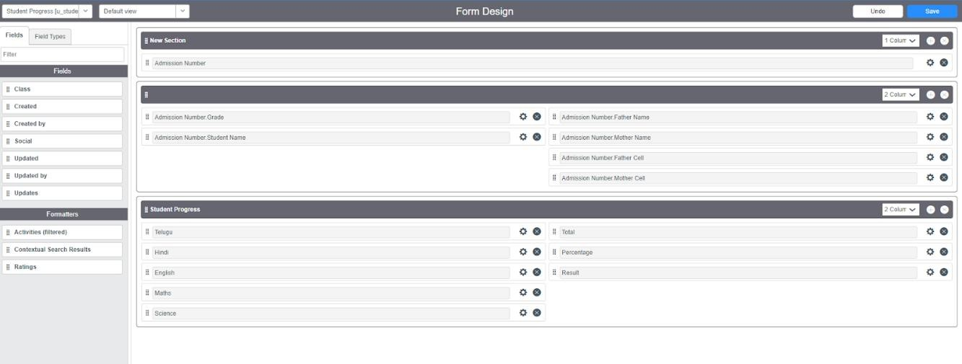

**Milestone5:Number Maintenance**

**Activity1: Creating Number Maintenance for Admin Number**

* + All >> Number Maintenance >> New

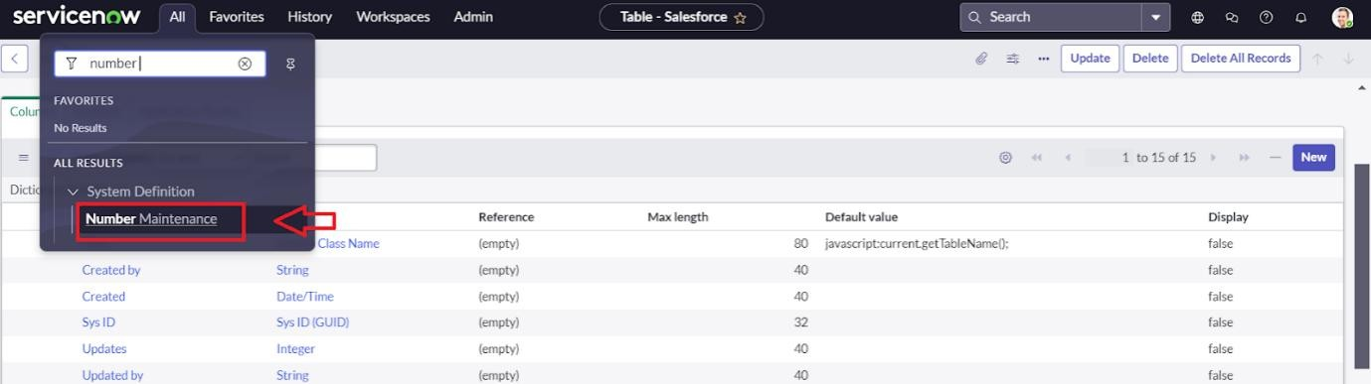

* + Fill the details >> Submit.

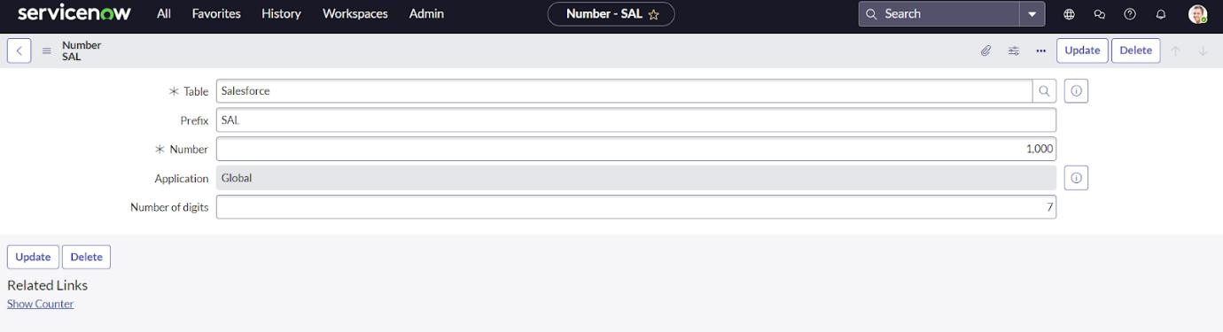

**Milestone6: Process Flow**

**Activity1: Creating Process Flow for Admission Table**

* + All >> Process Flow>> New.
  + Fill the Details as given Below

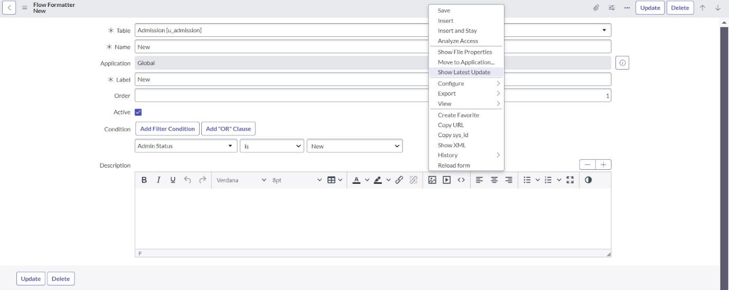

* + Right Click on toggle and click on the save .
  + Replace the Name and Label as below and click on Insert on stay.

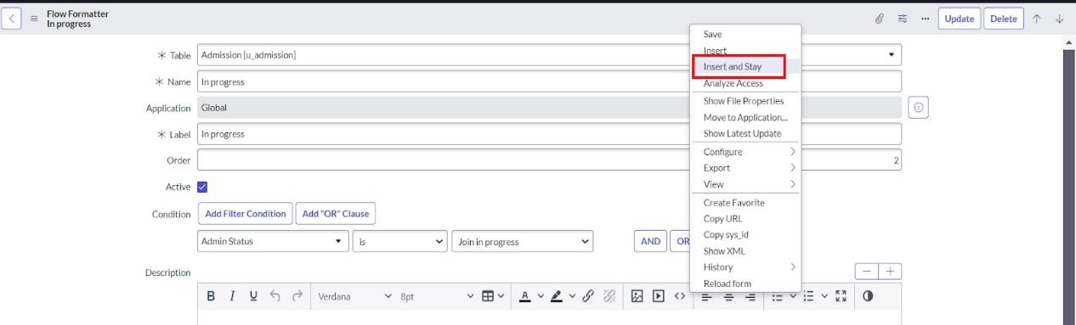

* + Replace the Name and Label in order and click on Insert on stay.

Joined >> Rejected >> Rejoined >> Closed >> Cancelled.

* + Order should be New >> InProgress >> Joined >> Rejected >> Rejoined >> Closed >>

Cancelled.

**Milestone7: Client Script**

**Activity1: Creating “Auto populate” Client Scripts for Admission Table**

* + All >> Client Scripts >> New.
  + Fill the Details as given.

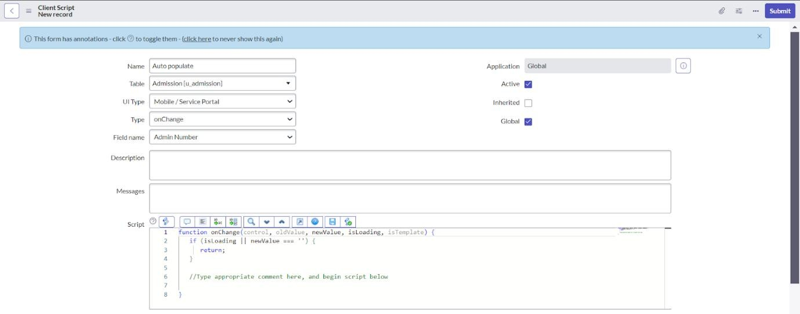

* + Write the Code as below, Enable Isolate script and Save.

function onChange(control, oldValue, newValue, isLoading, isTemplate) { if (isLoading || newValue === '') { return;

}

//Type appropriate comment here, and begin script below var a = g_form.getReference('u_admission_number'); g_form.setValue('u_admin_date',a.u_admin_date); g_form.setValue('u_grade',a.u_grade); g_form.setValue('u_student_name',a.u_student_name); g_form.setValue('u_father_name',a.u_father_name); g_form.setValue('u_mother_name',a.u_mother_name); g_form.setValue('u_father_cell',a.u_father_cell); g_form.setValue('u_mother_cell',a.u_mother_cell); g_form.setDisabled('u_admin_date',a.u_admin_date); g_form.setDisabled('u_grade',a.u_grade); g_form.setDisabled('u_student_name',a.u_student_name); g_form.setDisabled('u_father_name',a.u_father_name); g_form.setDisabled('u_mother_name',a.u_mother_name); g_form.setDisabled('u_father_cell',a.u_father_cell); g_form.setDisabled('u_mother_cell',a.u_mother_cell);

}

**Note**: Make sure the Field names should be the same as you created .

**Activity2: Creating “Pincode Update” Client Scripts for Admission Table**

* Fill the Details as given.

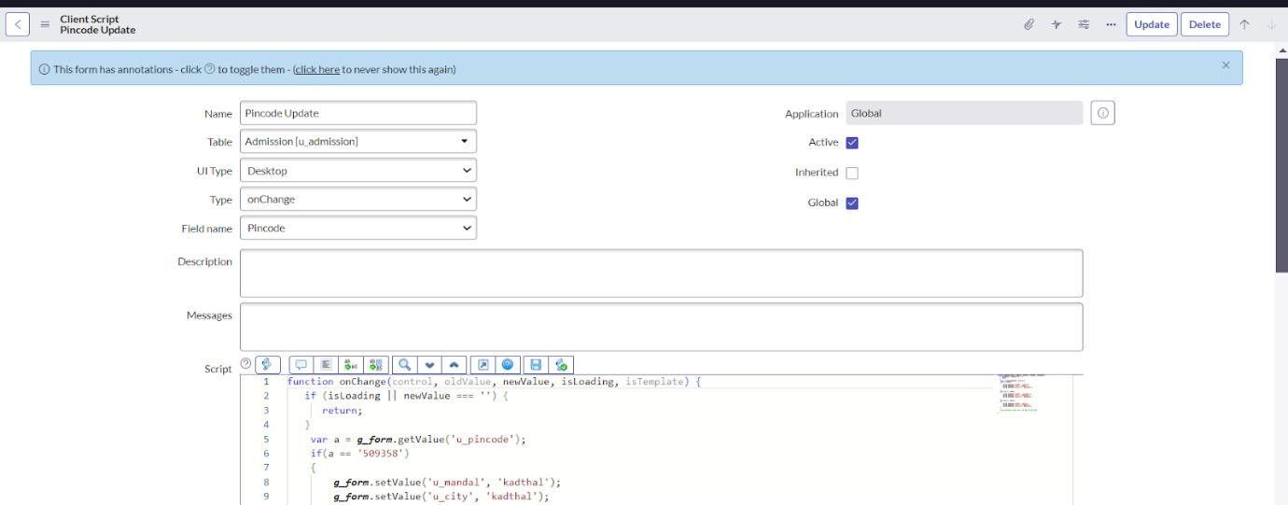

* Write the Code as below, Enable Isolate script and Save.

function onChange(control, oldValue, newValue, isLoading, isTemplate) { if (isLoading || newValue === '') { return;

}

var a = g_form.getValue('u_pincode'); if(a == '509358')

{

g_form.setValue('u_mandal', 'kadthal'); g_form.setValue('u_city', 'kadthal'); g_form.setValue('u_district', 'RangaReddy');

}

else if(a == '500081')

{

g_form.setValue('u_mandal', 'karmanghat'); g_form.setValue('u_city', 'karmanghat'); g_form.setValue('u_district', 'RangaReddy'); }

else if(a == '500079')

{

g_form.setValue('u_mandal', 'Abids'); g_form.setValue('u_city', 'AsifNagar'); g_form.setValue('u_district', 'Hyderabad');

}

//Type appropriate comment here, and begin script below

}

**Activity3: Creating “Disable Fields” Client Scripts for Student progress Table** • Fill the Details as given.

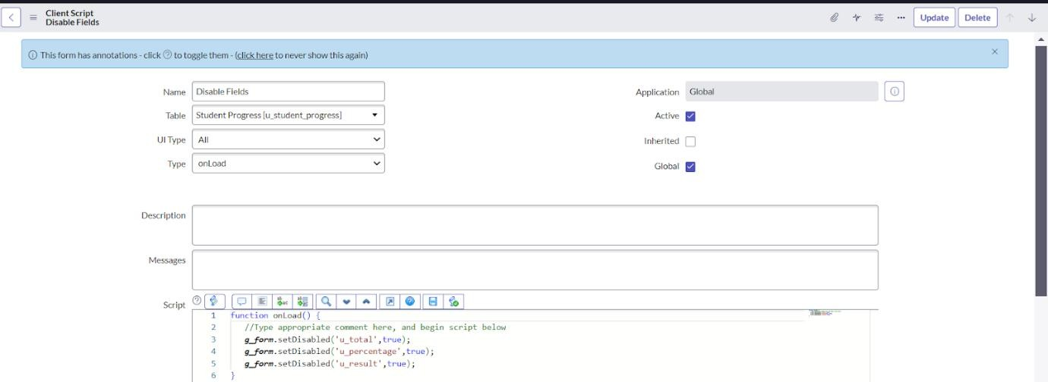

* Write the Code as below, Enable Isolate script and Save. function onLoad() {

//Type appropriate comment here, and begin script below

g_form.setDisabled('u_total',true); g_form.setDisabled('u_percentage',true); g_form.setDisabled('u_result',true);

}

**Activity4: Creating “Total Update” Client Scripts for Student progress Table** • Fill the Details as given.

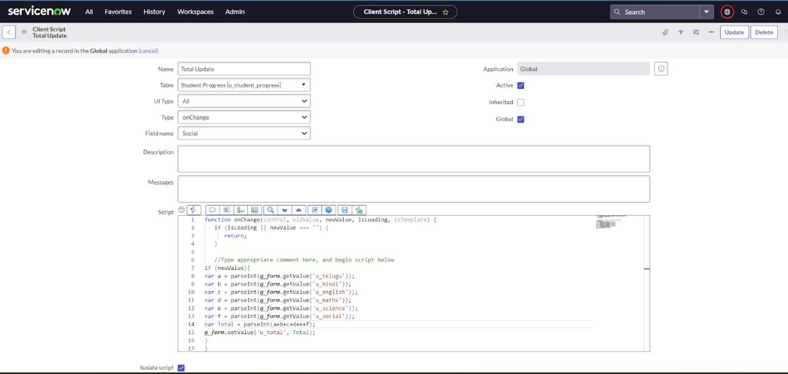

* Write the Code as below, Enable Isolate script and Save.

function onChange(control, oldValue, newValue, isLoading, isTemplate) { if (isLoading || newValue === '') { return;

}

//Type appropriate comment here, and begin script below if (newValue){ var a = parseInt(g_form.getValue('u_telugu')); var b = parseInt(g_form.getValue('u_hindi')); var c = parseInt(g_form.getValue('u_english')); var d = parseInt(g_form.getValue('u_maths')); var e = parseInt(g_form.getValue('u_science'));

var f = parseInt(g_form.getValue('u_social')); var Total = parseInt(a+b+c+d+e+f); g_form.setValue('u_total', Total);

}

}

**Activity5: Creating “Result” Client Scripts for Student progress Table** • Fill the Details as given.

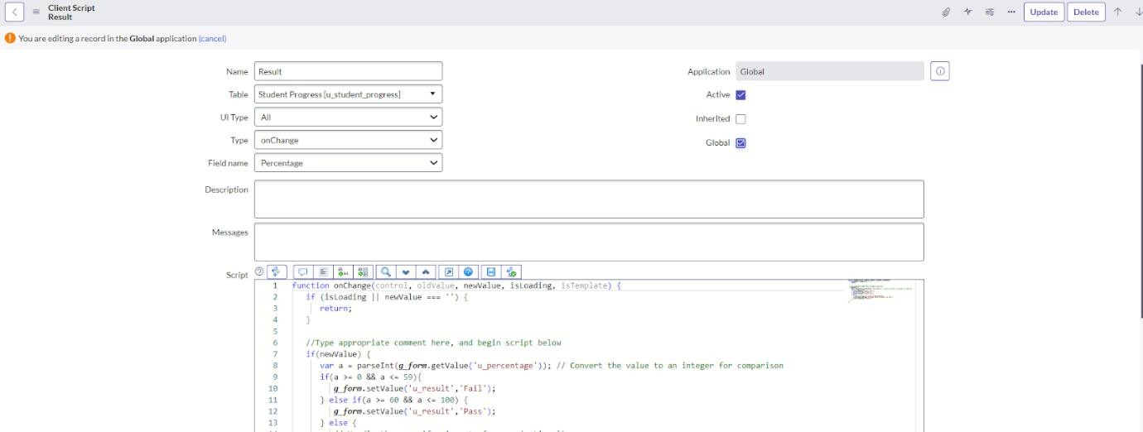

• Write the Code as below, Enable Isolate script and Save.

function onChange(control, oldValue, newValue, isLoading, isTemplate) { if (isLoading || newValue === '') { return;

}

//Type appropriate comment here, and begin script below if(newValue) {

var a = parseInt(g_form.getValue('u_percentage')); // Convert the value to an integer for

comparison if(a >= 0 && a <= 59){

g_form.setValue('u_result','Fail');

} else if(a >= 60 && a <= 100) {

g_form.setValue('u_result','Pass');

} else {

// Handle the case if a is out of range (optional) g_form.addErrorMessage('Percentage should be between 0 and 100.'); g_form.clearValue('u_result');

}

}

}

**Activity6: Creating “Percentage” Client Scripts for Student progress Table** • Fill the Details as given.

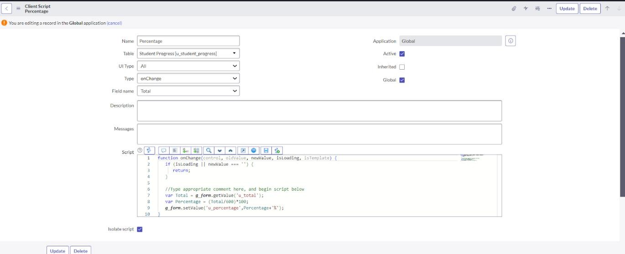

• Write the Code as below, Enable Isolate script and Save.

function onChange(control, oldValue, newValue, isLoading, isTemplate) { if (isLoading || newValue === '') { return;

}

//Type appropriate comment here, and begin script below var Total = g_form.getValue('u_total');

var Percentage = (Total/600)*100; g_form.setValue('u_percentage',Percentage+'%');

}

**Milestone8: Result**

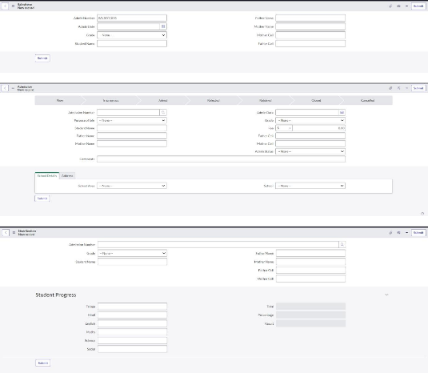

Conclusion:

Implementing ServiceNow in an educational organization helps streamline administrative tasks, improve communication, and enhance overall efficiency. By automating processes such as student support, IT services, HR requests, and facility management, the institution can save time and reduce manual errors. ServiceNow also provides a centralized platform where students, faculty, and staff can easily access services, track requests, and resolve issues quickly. This not only increases transparency but also improves the user experience. Ultimately, adopting ServiceNow enables educational organizations to focus more on delivering quality education and innovation rather than being slowed down by operational challenges.